TE HOPAI TRUST
Quality Report October 2020
Hand Hygiene
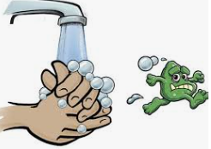
As part of our continuing attempts to ward off Covid and other illnesses, we are strongly encouraging all visitors to sanitise themselves on entry and exit to the facility. There is alcohol hand gel available at each entrance and also around the facility at stations on the wall.
Elections 2020
The Diversional Therapy team worked really hard to ensure all the residents who wanted to have a say in this year’s elections were able to do so. Around 90 residents were able to cast a vote, and so we thank the team for organising this for our residents.
Workforce
Many industries are struggling to fill vacancies now that our foreign workforce is in the main not permitted to enter the country. This is especially hard in aged care where a study reported “consistency in having the same care professional was seen as helpful, particularly in the case of participants with dementia, however, this was not possible in many cases due to the high turnover of staff” (Abdi, Spann, Borilovic, Witte & Hawley).
At Te Hopai, we are fortunate to have many staff members who have worked here for many years. This provides a degree of consistency for the residents and we strive to maintain a stable workforce. We do need to encourage more young people into the industry as our nursing workforce is ageing, with the Ministry of Health in 2016 reporting 45.2% of nurses are aged over 50.
Abdi, S, Spann, A, Borilovic, J. et al. Understanding the care and support needs of older people: a scoping review and categorisation using the WHO international classification of functioning, disability and health framework. BMC Geriatrics 19, 195(2019).
https://doi.org/10.1186/s12877-019-1189-9
Ministry of Health. 2016. Health of the Health Workforce 2015. Wellington: Ministry of Health.
Laundry
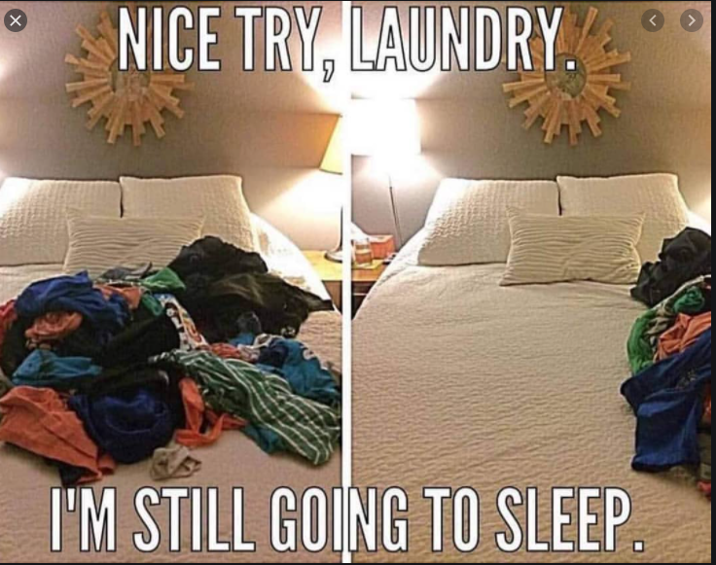
Recently we conducted a survey to find out what we were doing well and not so well. Some respondents were not entirely happy with the laundry service that we provide for personal laundry. We have accepted those comments and are trialling laundry bags that go into the washing machine and keep the resident’s laundry together through the washing process. Hopefully, this will reduce the number of items that become lost. Along with this, we would like to remind people we offer a labelling service for clothing, that is virtually guaranteed not to come off in the machines. We encourage people to use this service as Sharpie pens fade and quickly become indecipherable.
Gardens
We would like to say a big thank you to our gardener for keeping our garden areas looking so nice. The roses in the central courtyard look like they are going to have a bumper number of flowers on them. We also have an active garden area in Kowhai, where the residents who like to garden can get out with their diversional therapist and grow what they decide will look nice in this area. We are continuing to work on making the Kowhai garden even more attractive and interactive.
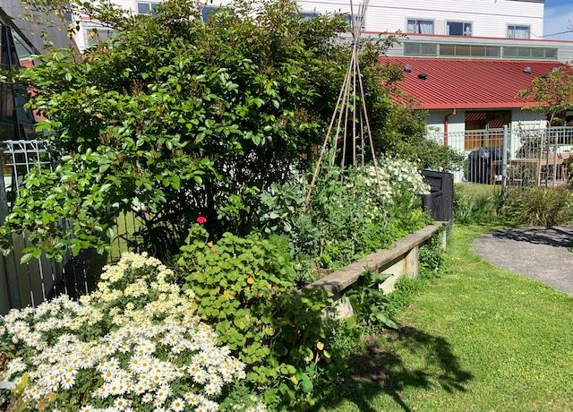
Kowhai garden

Volunteers
Our volunteers are a huge part of our recreational programme here at Te Hopai, and we thank them for all their hard work. Currently, we have several people volunteering who have musical talents and we are able to hold three concerts a week at the moment.

