TE HOPAI TRUST
Quality Report – March 2020
It seems like all the world is currently talking about the Covid-19 (coronavirus) outbreak and with older people especially at risk, aged care facilities like Te Hopai need to ensure that they are prepared for cases occurring within their organisations.
A large epidemiological study of 72,000 cases in China (Vital Surveillances: The Epidemiological Characteristics of an Outbreak of 2019 Novel Coronavirus Diseases (COVID-19) — China, 2020. China CDC Weekly 2020, 2(8): 113-122), revealed that people aged over 80 who contract the virus have a 14.8% chance of dying from COVID-19 whereas, in this study, no children under the age of 9 died and only one young person aged between 10-19 died. Rates of infection are very low for all age groups up to those aged 60 and over.

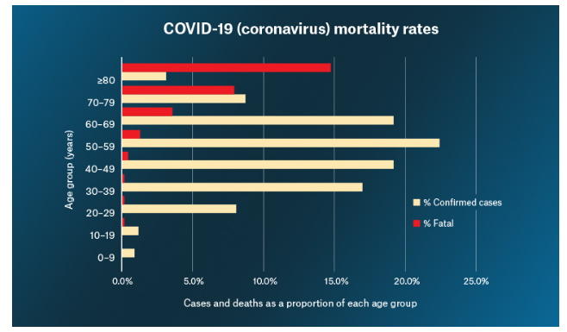
This means, that although coronavirus comes from the same family of viruses as the influenza viruses, its mortality patterns are very different.
Because of this, coronavirus will pose a major challenge to New Zealand’s ageing population and this includes those who live in aged care facilities.
Thus Te Hopai has already started preparing for such an eventuality. We have already reviewed our stock of personal protective equipment and although well stocked already, we have ordered more supplies to ensure we are amply covered.
We are sending out a letter to all those connected with our residents explaining that we are following the Ministry of Health guidelines and expect anyone who fits the criteria to stay away. That means that anyone who has travelled from the “at risk” countries or anyone who has been in contact with a confirmed case, must self-isolate for 14 days from the point of contact and not come to Te Hopai to visit anyone.
We are also requesting that anyone who visits, performs hand hygiene before entry to the facility, using the alcohol hand sanitiser which is provided at the entrances to the building. It may become the case that we need to lockdown the facility if the outbreak becomes widespread, as we have to do sometimes during a norovirus outbreak.
Our staff will also be screened for their suitability to work and they will be asked before taking annual leave where they intend to travel. Any staff member who visits an at-risk country or who is in contact with an infected person, will follow the self-isolation guidelines.
We all need to do our part to help prevent the spread of Covid-19 by practising good hand hygiene and cough/sneeze etiquette. Please be aware that this virus does not spread as much as people think it does, it does take some time and exposure and it is not as contagious as the measles. However people are most infectious when they are symptomatic, some people have very mild symptoms and are not aware they are ill, so that is why our facility will be vigilant and be screening visitors as much as we can.
However, there are times when visitors arrive outside the times our reception staff work so please help us to keep the residents as safe as we can. If you have any questions, don’t hesitate to contact our general manager or one of the care managers.

International Women’s Day
In 1975 the UN recognised International Women’s Day as a day dedicated to the rights of women, but it came into existence long before that. It was first celebrated in Austria, Denmark, Germany and Switzerland in 1911, and in some countries was soon established as a public holiday.
This year we are celebrating it on Sunday March 8th and various events are occurring across the country to mark the day. The theme this year is ‘Creating an Equal and Enabled world’.
In Wellington the guest speakers are the Hon. Julie Anne Genter – Minister for Women, Tiana Epati – President of the Law Society, and Dr Lupe Taumoepeau – NZ’s first female vascular surgeon. All tickets are sold out to the event but it can be live-streamed on http://www.eventspronto.co.nz/livestreamIWD2020?fbclid=IwAR1eO7K9y1ehJCL3BZsNUIgLzuOF6E1gea5aHl0QuMPWUCBTEJKUcpVGYzc
The year 2020 represents an unmissable opportunity to mobilise global action to achieve gender equality and human rights of all women and girls!

Changes to the workforce
It is predicted by 2060 there will be around 746,000 new employees aged over 65 years of age in the workforce. This will dramatically change the working landscape when compared to the traditional model of workers retiring at 65.
This will happen for a variety of reasons, including the fact that today’s over 65s are living longer, healthier lives and can continue working if they want to, those topping up their pension pots, those who want to keep working because they love their jobs and those who are doing it for health and well-being reasons.
The number of over-65s who are employed has increased by 188% in the last 20 years, from 455,000 to 1.31 million, and the proportion has grown from just over 5% to just under 11%. Some current employers need to stop being prejudiced against older workers and realise they are a valuable resource that can solve labour shortages. The over 65 workforce is talented and highly skilled, and it is common sense to make use of these longer working lives. Older workers should be considered essential to an effectively balanced team and when the right leadership skills are shown, they can offer valuable experience that is difficult to find elsewhere.
Thus, in the future we may see nurses and health care assistants who are the “young elderly” looking after the “old elderly” in our rest homes.

