Quality Report – July 2020
Fundraising
We would like to thank all those people who have donated so far to our fundraising efforts and raffle. We are a third of the way to our goal. The money will go towards the purchase of a visitor management system as well as a thermal scanning device to assist us keeping our residents well and unwanted illnesses into the facility.
Shortly we will start selling raffle tickets shortly for the items we have collected.
Although our primary aim is keeping Covid out of the facility, we have developed an ongoing plan for the management of a Covid outbreak at Te Hopai. This has been approved by the DHB Infection Control team and any of our Clinical/Care Managers can discuss our plans with you.
We are continuing to limit our ‘open hours’ to the 10am-4pm window so that we can maintain our ‘sign-in – sign out’ oversight. We know that this is difficult for some of you, especially those who work, so if you are unable to visit during these hours, please let us know by and we will see what we can do to accommodate you.
Winter
We monitor infection rates in the facility all year around, and we usually notice a spike in respiratory tract infections throughout the winter months. In younger, healthy people, these viral illnesses pass without issue, but in older adults, with co-morbidities, the viral illness sometimes can progress onto a lower respiratory tract infection/pneumonia. In July, we noticed our first spike of the year and this can be attributed in part to more visitors bringing in colds and influenza like illnesses into the facility.
We ask that all visitors do not visit if you are unwell with any type of symptoms. Illnesses can pass very quickly from person to person and our goal is to keep our residents as healthy as we can.
Satisfaction Survey
It is that time of the year again – satisfaction survey time. I know that these days, we are all inundated with surveys about things we buy and things we do. However, it is only by asking your opinion about our services, that we can find out if you are happy with the care we are providing.

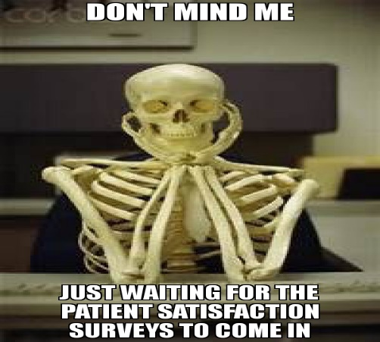
Rino Roh (RN Rest Home and part-time quality data collector) is responsible for sending out the surveys this year, and so far, he has had a 30% response rate. We encourage all of you who have been sent a survey to fill this in and send it back to us. We post a response in this website newsletter so that you can see what we are doing well and what we need to improve on. We also let you know what we are doing to improve so that you can be sure we have taken notice of your comments, and that we are trying to make our service better.

Telemedicine
Due to the Covid pandemic, many services have been forced to change the way they do things and this also includes visits to the doctor. Many GPs are now carrying out virtual consultations via telemedicine, but a study published in the Journal of the American Medical Association has found that a large proportion of older adults are not prepared to be able to access online doctor’s visits because of issues with using technology.
“Video visits require patients to have the knowledge and capacity to get online, operate and troubleshoot audiovisual equipment, and communicate without the cues available in person. Many older adults may be unable to do this because of disabilities or inexperience with technology.”(p.E1)
The authors estimate that 38% of those surveyed were unready for using telemedicine, with 30% of these being unready because they were unexperienced with the technology. Often these adults were already disadvantaged and these findings expose the worry that these groups will become further disadvantaged if this method of communicating with a physician becomes the norm.
Thus, it is important that older people get access to courses designed to upskill their use of technology and SeniorNet is a community training network that supports and motivates people to enjoy and use technology in their everyday lives. They specialise in improving the computer skills of seniors and older adults. Their web address is located at https://seniornet.co.nz/
Published Online: August 3, 2020. doi:10.1001/jamainternmed.2020.2671

