TE HOPAI TRUST
Quality Report – April 2020
Coronavirus update - we recently had an assessment by the infection control team at the DHB, to check that we are prepared to manage an outbreak of Covid 19 in the facility. We received the report and there were no recommendations that the DHB could make; they felt we were well prepared and that they felt confident we could manage an outbreak if we had one.
This is testament to the hard work that the staff have put in to prepare themselves for such an eventuality. All the staff have been very receptive to the training offered and a lot of work has gone into writing procedures and processes so that the staff know exactly what to do in the event of an outbreak.
Ombudsman
The Ombudsman monitors aged care facilities to prevent human rights violations occurring and he will be making visits to aged care facilities to check if residents are being treated fairly whilst in lockdown due to the Covid 19 pandemic.
Mr Boshier stated “my role is to provide independent oversight of the treatment of some of the most vulnerable people in the aged care sector — people who are kept in locked facilities because of dementia or some other cause.”
“I believe the public needs reassurance about two things — that the facilities are doing all they can to prevent the virus from spreading to those most at risk, and that steps are being taken to make sure the basic human rights of residents are protected.”
“I have also been concerned at local media reports about the dislocation of families during the lockdown, where residents have little or no access to their loved ones.”
He welcomes the decision by the Director General of Health to order a review of the facility outbreaks and to write to District Health Boards asking them to systematically assess the readiness of aged residential care providers in their area.
The Chief Ombudsman has established a set of principles to guide facilities and their staff in managing this crisis, while meeting New Zealand’s international human rights obligations:
- There remains an absolute prohibition against torture and inhuman or degrading treatment of detained people, which must be upheld
- All possible action must be taken to protect the health and safety of all detained people
- When detained people are suspected of, or confirmed as, having COVID-19, they should be able to access urgent, specialised healthcare without fuss. This is in line with the duty to provide equivalent care to those in the wider community. Special attention will be required to ensure that the needs of detained at-risk people, such as older people and people with pre-existing medical conditions, are met. This includes screening for COVID-19, and providing pathways to intensive care as required
- Detained people may require additional psychological support at this time
- Any restrictive measures taken against detained people to prevent the spread of COVID-19 should be proportionate, lawful, accountable, necessary, and non-discriminatory. The measures must respect human dignity, be of limited duration, and regularly reviewed. People deprived of their liberty and their whānau should receive comprehensive information about these measures in a way they understand. Specific measures and the reasons for them should be recorded
- The fundamental rights of detained people during the pandemic must be fully respected. This includes, in particular, the right to maintain personal hygiene (including access to hot water and soap) and the right of daily access to the open air (of at least one hour). Any restrictions on contact with the outside world, including visits by whānau and legal advisors, should be compensated for by increased access to alternative means of communication (such as telephone or Voice-over-Internet-Protocol communication)
- In cases where a detained person is isolated or placed in quarantine because they are infected or suspected of being infected by the COVID-19 virus, they must be provided with meaningful human contact every day
- Detained people should be made aware of their rights and ability to complain, including how to raise concerns or issues they have with any increased restrictions. Contact information for assistance should be clear and accessible. Having questions answered or frustrations listened to is key to creating a safe and supportive environment.
We are confident that we meet all the expectations and that the residents are being enabled to maintain contact with relatives via facetime, Skype and other face to face applications. We have started up van trips again since the move to level 3 and have been providing extra recreational activities whilst the residents have not had access to visits by their relatives and friends.
Also, as stated above, after our DHB inspection we can be confident that we are in a position to a) reduce the chance of the virus entering the facility in the first place and b) that we can limit the spread of the virus if it were to enter the facility. We plan to cohort residents and staff so that the residents will have adequate access to care and we have always had excellent medical coverage with GPs visiting regularly and also being on call after hours.
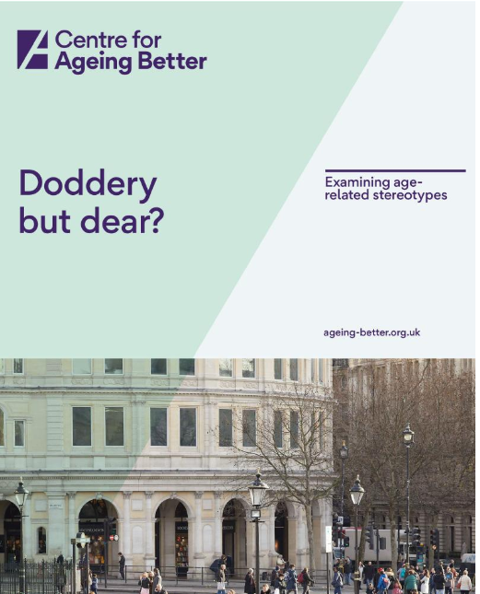
A new report by the Centre for Ageing Better has released a report entitled “Doddery but Dear” which examines the age-related stereotypes that still exist in today’s Western Societies.
They state that “media representations tend to draw more on negative stereotypes, reflecting a traditional ‘deficit’ narrative of ageing being associated with inevitable decline (reviewed in Bugental & Hehman, 2007; Kesby, 2017). Within print media, older people are represented as being more of a burden than benefit, with a huge dearth of positive images of older people (Bai, 2014; Martin, Williams, & O’Neill, 2009; Rozanova, 2010). Metaphors such as ‘grey tsunami’, ‘demographic cliff’ and ‘demographic timebomb’ present old age in terms of crisis, reflecting a perception of old age and the ‘baby boomer’ generation as a societal burden (Sweetland et al, 2017; Kesby, 2017) and encouraging negative feelings toward the older population” (pg. 9).
They conclude that stereotypes and attitudes towards ageing and older people tend to be more negative than positive. This results in prejudice and discrimination and also it is damaging to us if we are influenced to think about our own ageing in this way.
It has become clear through the Covid epidemic and the omission of the statistics from Rest Homes in the UK of those residents that have died from Covid, that these attitudes are pervasive and are held by those who make policies. They set generations against each other in a battle over resources and this needs to be challenged. One of the ways to do this is to readdress the balance and encourage more realistic depictions of ageing in traditional media, social media and policy-making circles.
Quality Adviser
Sam Ogilvie

